Mark Nandor – mjn18

EECS 473

Problem Set 1 – simulated controller

To run

1) roslaunch minimal_sim.launch

2) run sin_commander node. This will prompt user for desired amplitude and frequency.

**

The resultant system follows the above node graph. Velocity command is generated by the commander, passed along to the controller. Controller generates a force command, which is sent to the simulator. Velocity feedback is given to the controller.

Effect of Kv

For this set of experiments, the velocity is commanded at 1 Hz frequency, 1 m/s amplitude. Three values of Kv are selected – 1, 10, and 100. These selections show the variety of possible system responses.

At Kv = 1, we see poor system performance. The system is unable to acceptably track the commanded signal.

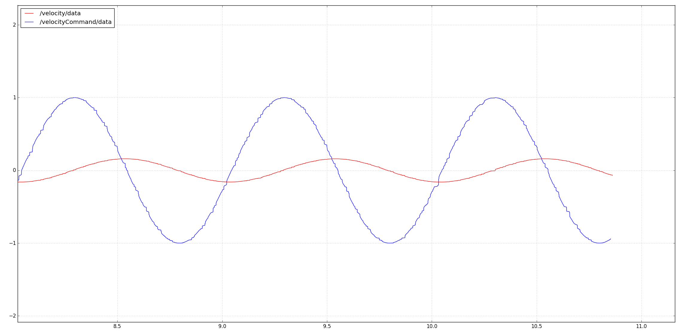

At Kv = 10, system performance is much enhanced. The output is able to track the input with minimal lag.

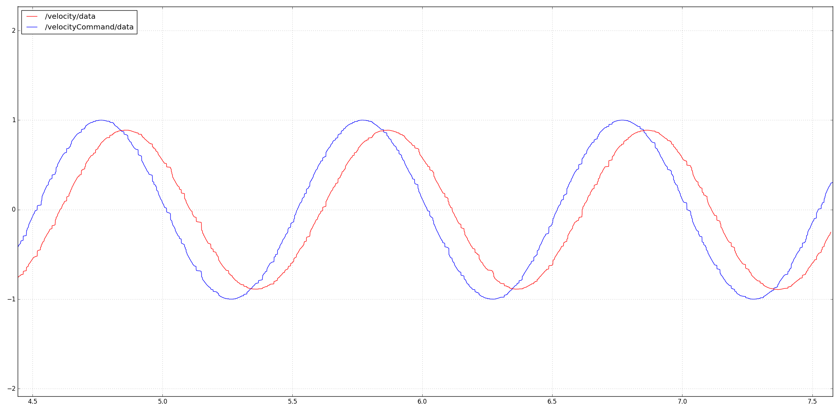

At Kv = 100, the controller causes the system to be unstable, oscillating and very large amplitudes and at frequencies much higher than the commanded frequency.

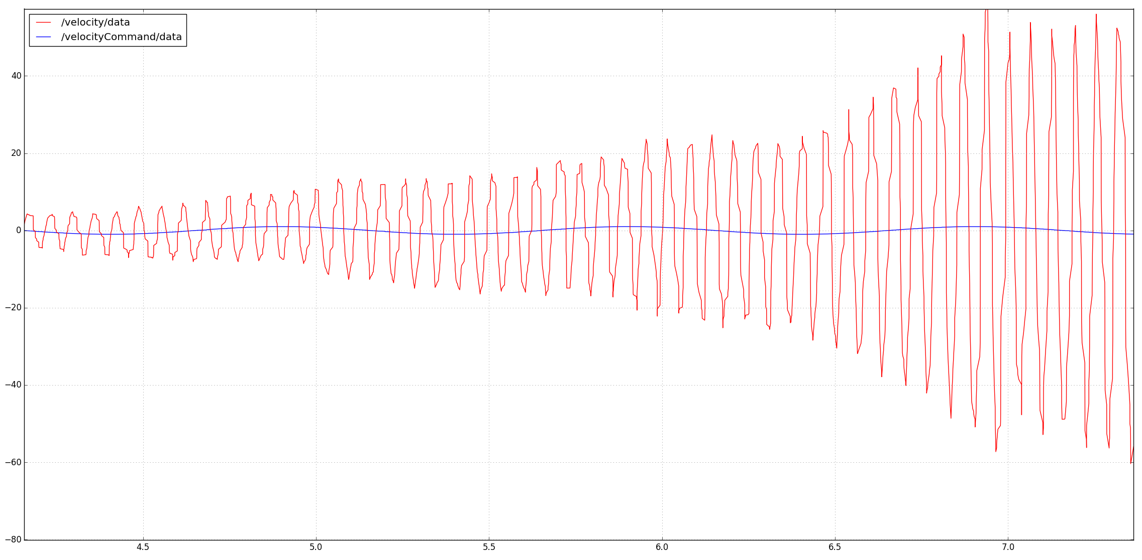

Recommended Kv is 30.0, based on trial and error experimentation.

Effect of dt in simulator and controller.

To demonstrate the effect of simulation and controller frequency, a series of experiments is performed. All demonstrations utilize a 1 m/s command operating at 1 Hz.

This first experiment sets both controller frequency and simulation frequency at 10 Hz.

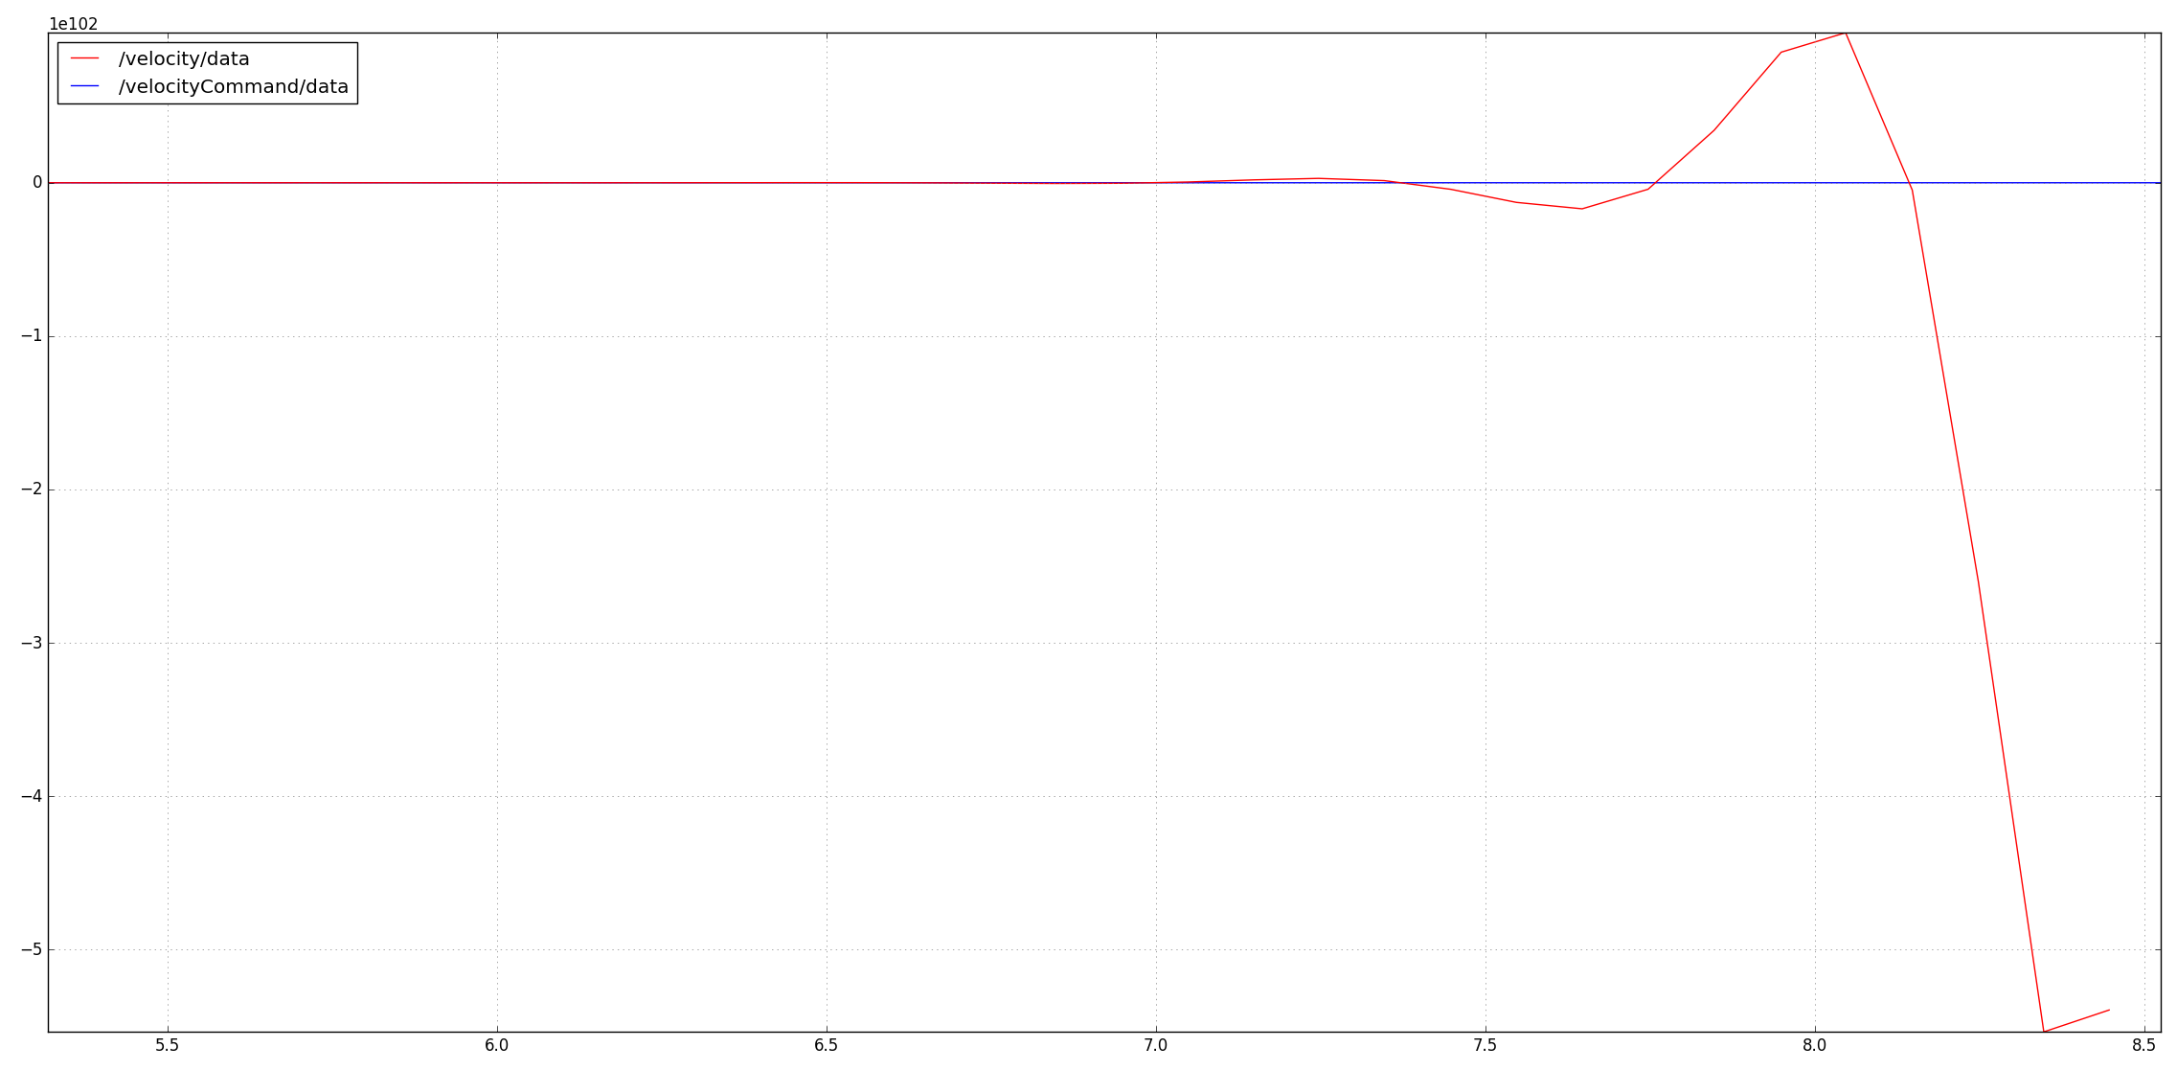

Note the scale on the y axis. This is not stable. That is bad.

Both simulator and controller frequency are increased to 100 Hz here:

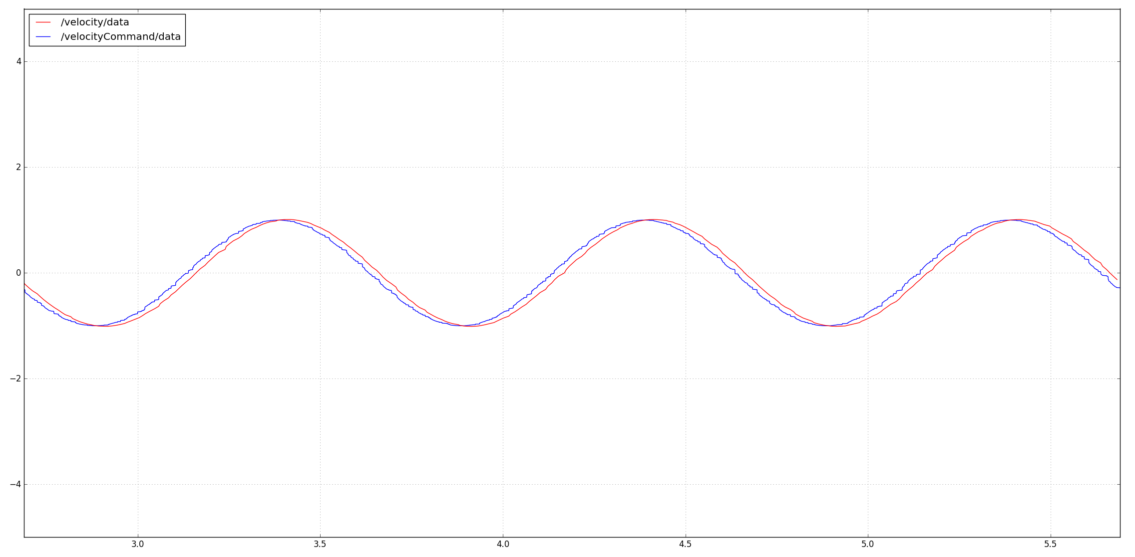

Here, signal tracking and performance are much improved.

Minimal improvement is noted with an increase to 1000 Hz for both controller and simulator.

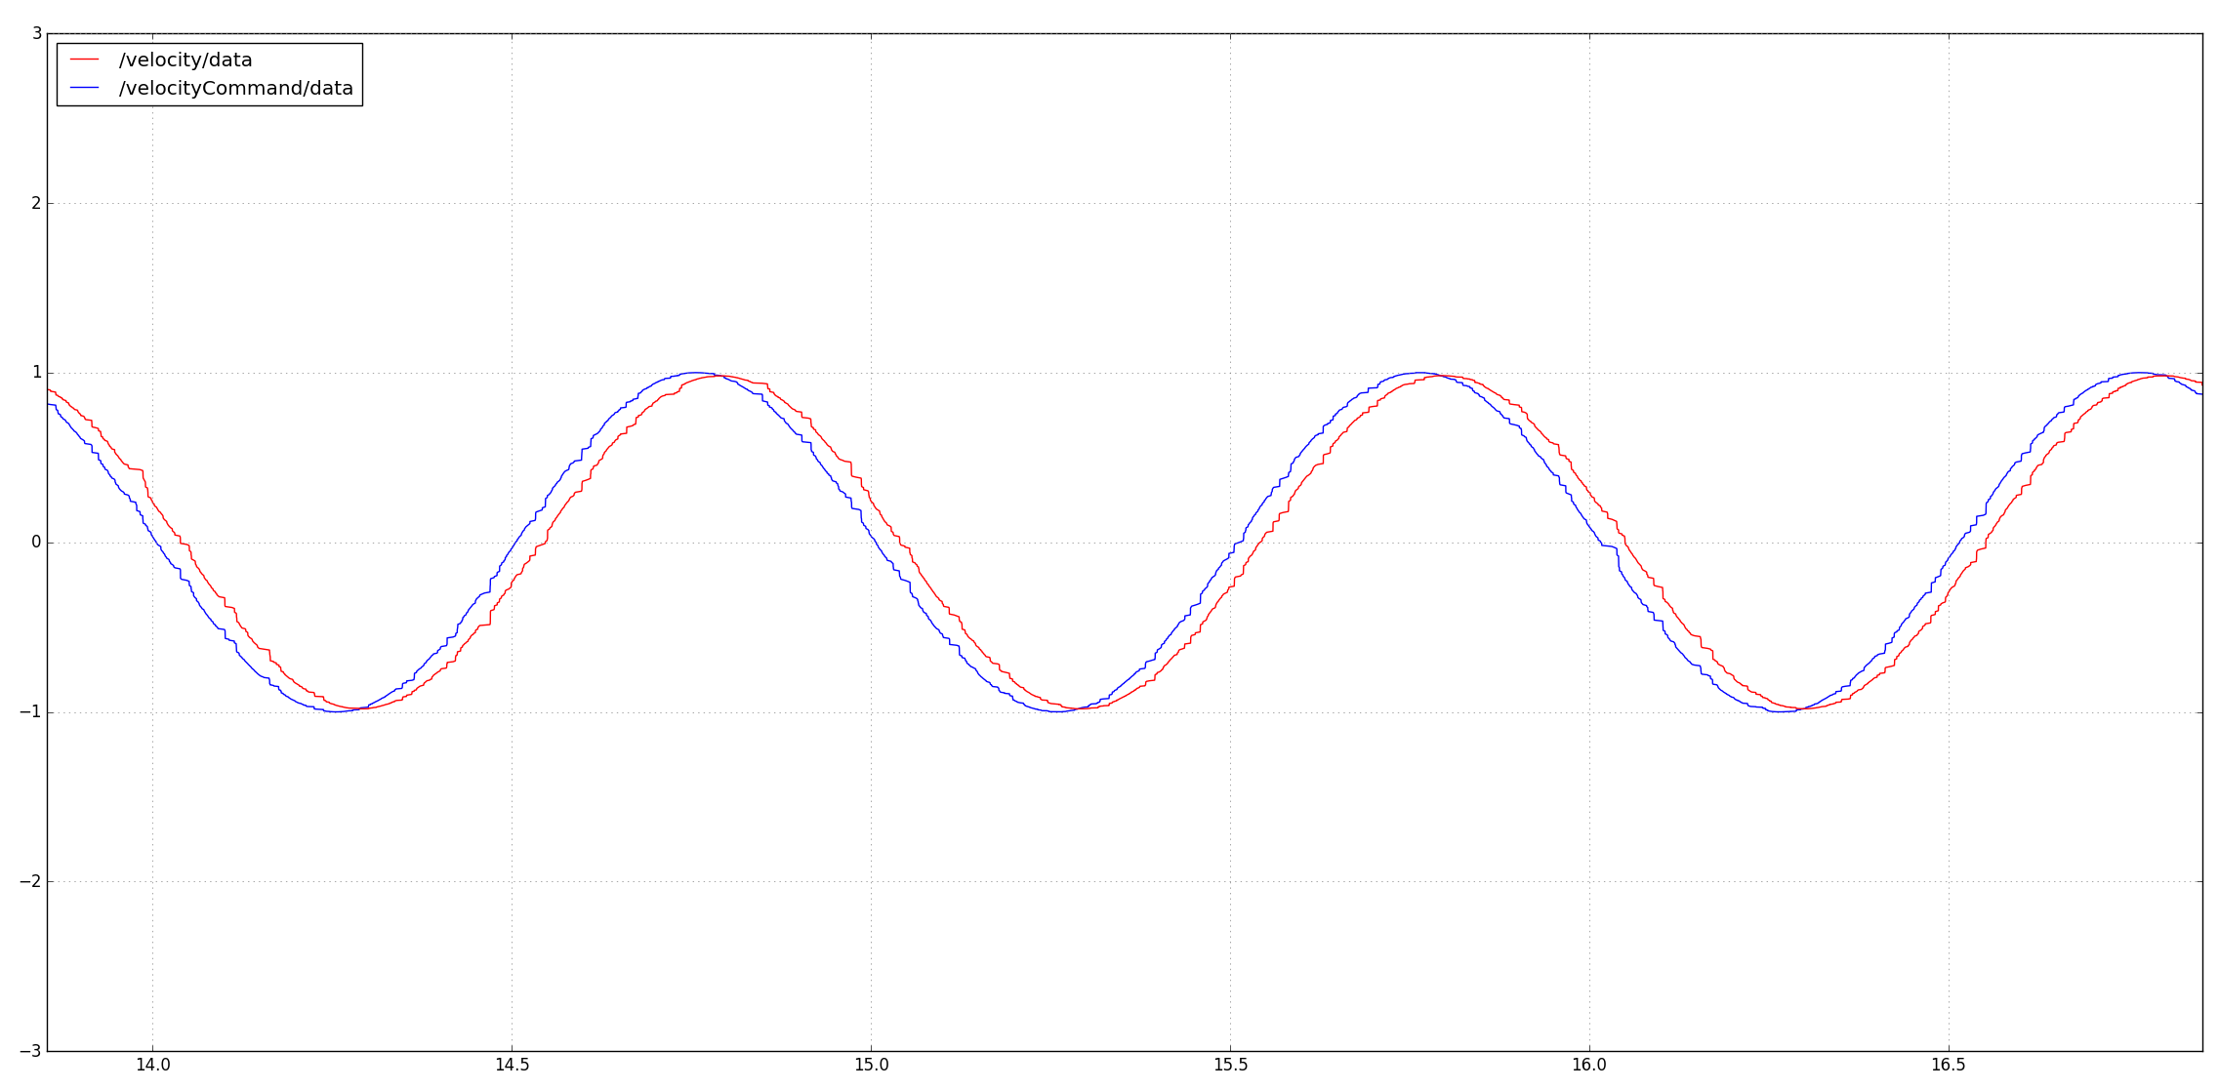

100 Hz is recommended as minimum operating frequency (2 orders of magnitude higher than the commanded signal.